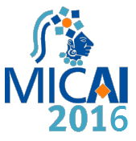
ACCEPTANCE LETTER
Aguascalientes, Ags., February 2017
Dear Authors:
Mary Arely López Garrido, José Alberto Hernández Aguilar, Carlos Alberto Ochoa Ortiz, Erika Yunuen Morales Mateo1 and Carolina González Constantino

Thank you for submitting your work to the Hybrid Intelligent Systems (HIS) Work Shop. I am pleased to tell you that your work:
Comparative study of learning strategies of students of Bachelor in Nursing

Has been accepted for publication in an special issue of the Journal Research in Computing Science title Hybrid Intelligent Systems, published by National Polytechnic Institute, Mexico, which is an internationally refereed open access scientific research journal.
Next steps are: If the manuscript is accepted or accepted with minor revision, later of the modifications realized for the author. Once the final version is ready, the paper is announced and becomes available for all audiences.
Regards

PHD. Julio Cesar Ponce Gallegos
E-mail: jcponce@correo.uaa.mx
Chair at IX HIS Workshop
MICAI’2016

